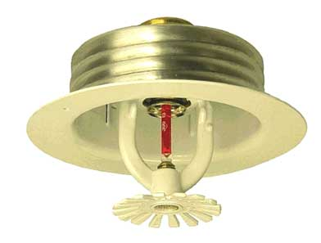

Engineering Specification
Model F1FR Quick Response
Automatic Sprinklers

Pendent, Upright, and Conventional Styles

Sprinklers shall be a standard coverage, quick response [spray sprinkler upright] [spray sprinkler pendent][conventional sprinkler] that is [cULus Listed][FM Approved [NYC MEA Approved – 258-93-E]. Sprinkler frame and deflector shall be of bronze frame construction having a [½”][ ¾”] NPT thread. Water seal assembly shall consist of a Teflon-coated Belleville spring washer and top-loaded extruded cup with 3 mm glass bulb containing no plastic parts. Sprinkler temperature rating shall be [135 °F (57 °C)] [155 °F (68 °C)] [175 °F (79 °C)] [200°F (93°C)] [286 °F (141 °C)]. Sprinklers shall have a nominal K-factor of [2.8 (40) – small orifice] [4.2 (61.0) – small orifice] [5.6 (81.0) – standard orifice] [8.0 (115) – large orifice]. Small orifice sprinklers shall be used in wet pipe systems and light hazard occupancies only. Sprinklers shall have a rated working pressure of 175 psi (12.1 bar). Standard finish: [Bronze] [Chrome-plated] [White Polyester] [Special finish– specify]. Refer to Reliable Bulletin 136 for associated sprinkler identification number (SIN) with respect to style, orifice size and thread combination.

Escutcheon Options

Model F2 escutcheon

Recessed escutcheon assembly shall be a steel, two-piece, friction-fit escutcheon with 1/2” adjustment. Standard finish shall be [brass][bright chrome] [white painted]

Model FP escutcheon

Recessed escutcheon assembly shall be a steel, two-piece escutcheon utilizing a push-on/ thread-off design with ½” adjustment. Standard finish shall be [bright chrome] [white painted]

