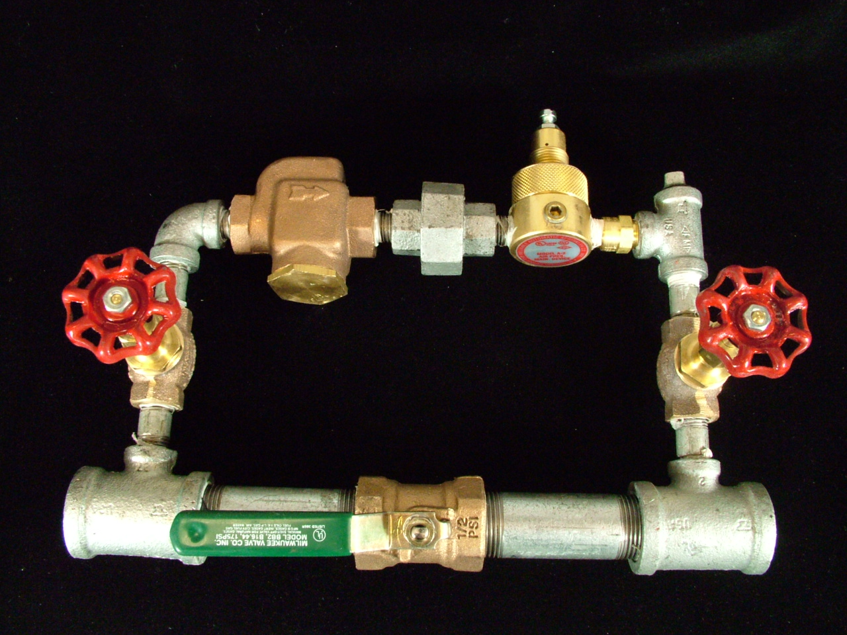

Model A-2 Pressure Maintenance Device
Regulating Type

An automatic, regulating type of pressure maintenance shall be used with pneumatic supplies provided by a source of compressed air or nitrogen cylinders equipped with a regulating device. The pressure maintenance device shall be [cULus Listed] [FM Approved] capable of maintaining a constant system pressure, automatically, regardless of any pressure fluctuations from the compressed air of nitrogen source. The device shall be constructed of galvanized trim and brass parts, consisting of ¼” supply bypass piping and a ¾” section of piping for rapid restoration of system pneumatic pressure. The ¼” bypass piping shall contain shutoff valves, a strainer, a check valve and a field adjustable pressure regulator. The pressure regulator shall have an adjustable outlet pressure range of 5 to 50 psi (.34 to 3,4 bar). The ¾” section of piping shall contain a ball valve for rapid restoration of system pressure and associated trim for connection to the dry pipe valve system air supply line. The assembly shall have a working pressure rating of 175 psi (12,1 bar). The pressure maintenance device shall be a Reliable Model A-2.

