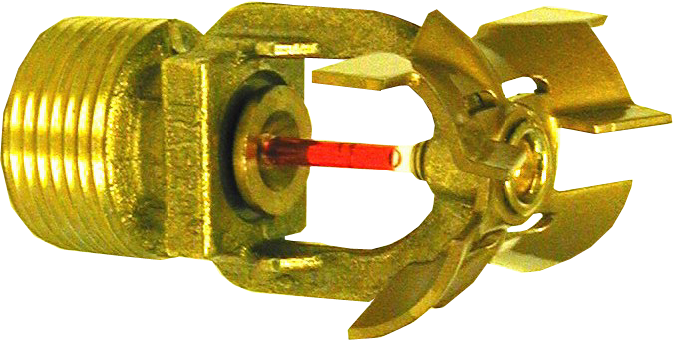

Engineering Specification
Model DH80 Quick Response
Extended Coverage Horizontal
Sidewall Sprinkler

Sprinklers shall be a quick response [cULus Listed] New York City MEA Approved (258-93-E)] extended coverage horizontal sidewall sprinkler for light hazard occupancies. Sprinklers to be of bronze frame construction with a special deflector capable of providing a discharge over a coverage area of 28 ft. wide, and 14 ft. horizontal throw. Water seal assembly shall consist of a Teflon-coated Belleville spring washer and machined brass cup with 3 mm glass bulb containing no plastic parts. Installation shall permit sprinkler deflectors to be positioned 4“ to 12” below the ceiling. Sprinklers shall have a nominal K-factor of 8.0 (115.3), and ¾” NPT thread. Sprinkler temperature rating shall be [135 °F (57 °C)][155 °F (68 °C)]. Rated working pressure shall be 250 psi (17.2 bar). Standard finish: [white][chrome][bronze][Special finish– specify]. Quick response horizontal sidewall sprinklers shall be Reliable Model DH80, SIN RA0362 (Bulletin 003).

For recessed horizontal sidewall sprinklers: Replace “horizontal sidewall” with “recessed horizontal sidewall.” Add: (1) Recessed escutcheon assembly shall be a factory-assembled, two-piece steel escutcheon of push-on and thread off design with ½” adjustment. Standard finish shall be [chrome] [white]; or (2) Recessed escutcheon assembly shall be a two-piece “friction fit” escutcheon with ½” adjustment. Standard finish: [white][chrome][bright brass][Special finish– specify]. Quick response recessed horizontal sidewall sprinklers shall be Reliable Model DH80, SIN RA0362 (Bulletin 003).

For concealed horizontal sidewall sprinklers: Replace “horizontal sidewall” with “concealed horizontal sidewall.” Add: Cover plate assembly shall consist of a brass, slot-less cover plate and copper alloy retainer flange. Method of attaching the cover plate to the sprinkler cup shall be a push-on and thread-off design allowing a ½” cover plate adjustment. Cover plate temperature rating shall be 135 °F (57 °C). A plastic protective cap shall be provided and factory installed inside the sprinkler cup to protect the sprinkler from damage, which could occur during construction before the cover plate is installed. Standard cover plate finish: [white] [Custom Color– specify]. Quick response concealed horizontal sidewall sprinklers shall be Reliable Model DH80, SIN RA0362 (Bulletin 003).

